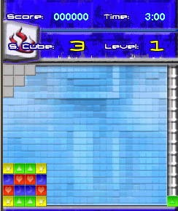
Figure 9: Conceptual Framework for the Cubies A 2D Mobile Game
EVALUATION OF
THE WHOLE
PROGRAM

Information From
- Books
- Journals
- Electronic sources
  - Internet
Technology
    - Hardware
      - Mobile phone 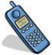
      - Personal Computer
    - Software
          - Java
          - J2ME
          - Image Editor

- To design a mobile game for colored mobile phones.
- To develop a game program for mobile phones.
- To test and implement the game program.
INPUT
PROCESS
OUTPUT

